**EC2 MariaDB Server Student Database**

1. Deploy one EC2 Compute Instance.

Log in to AWS account (Use either root or IAM account, don’t use both)

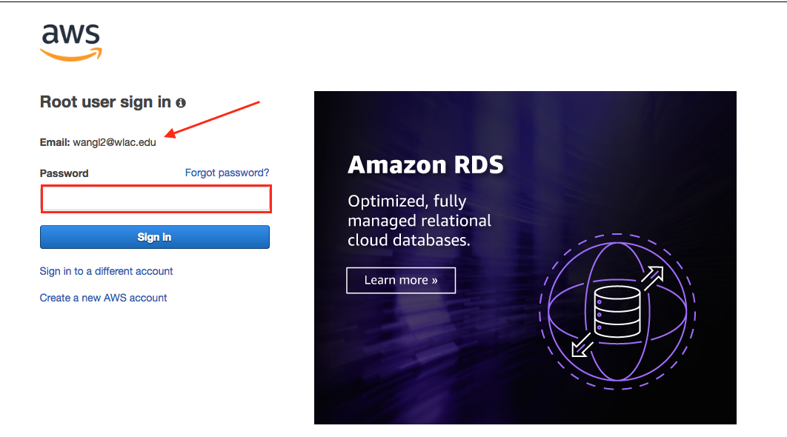

Click “Services”, select “EC2” from under “Compute”

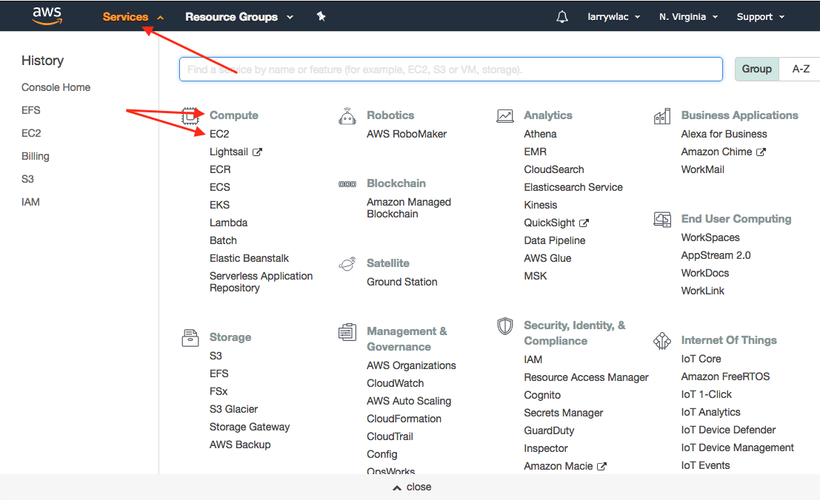

Click the “Launch Instance” button.

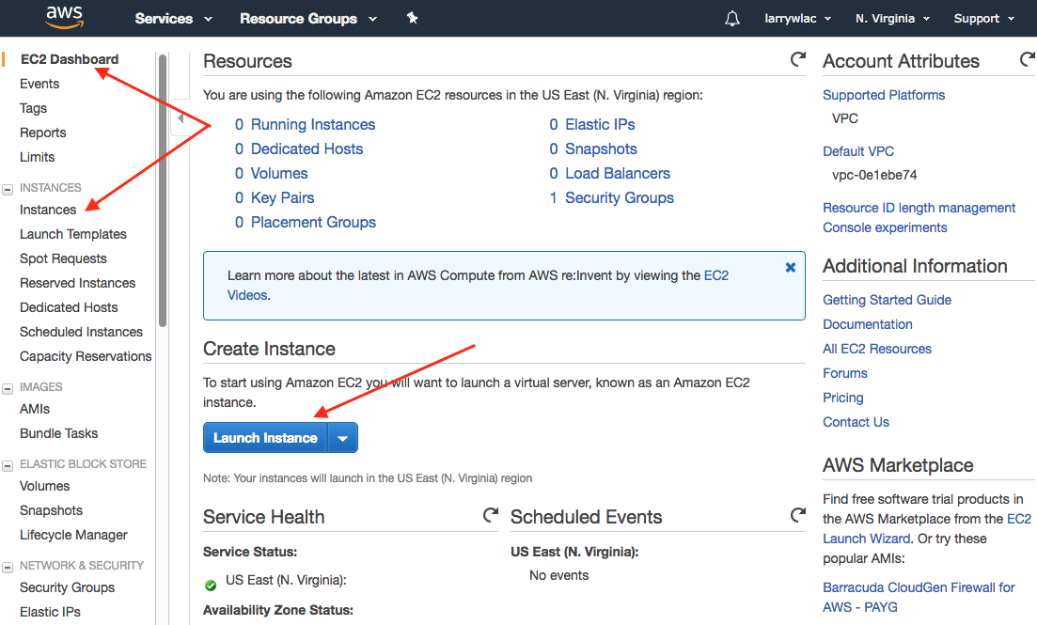

Select Amazon Linux AMI (not the ARM version)

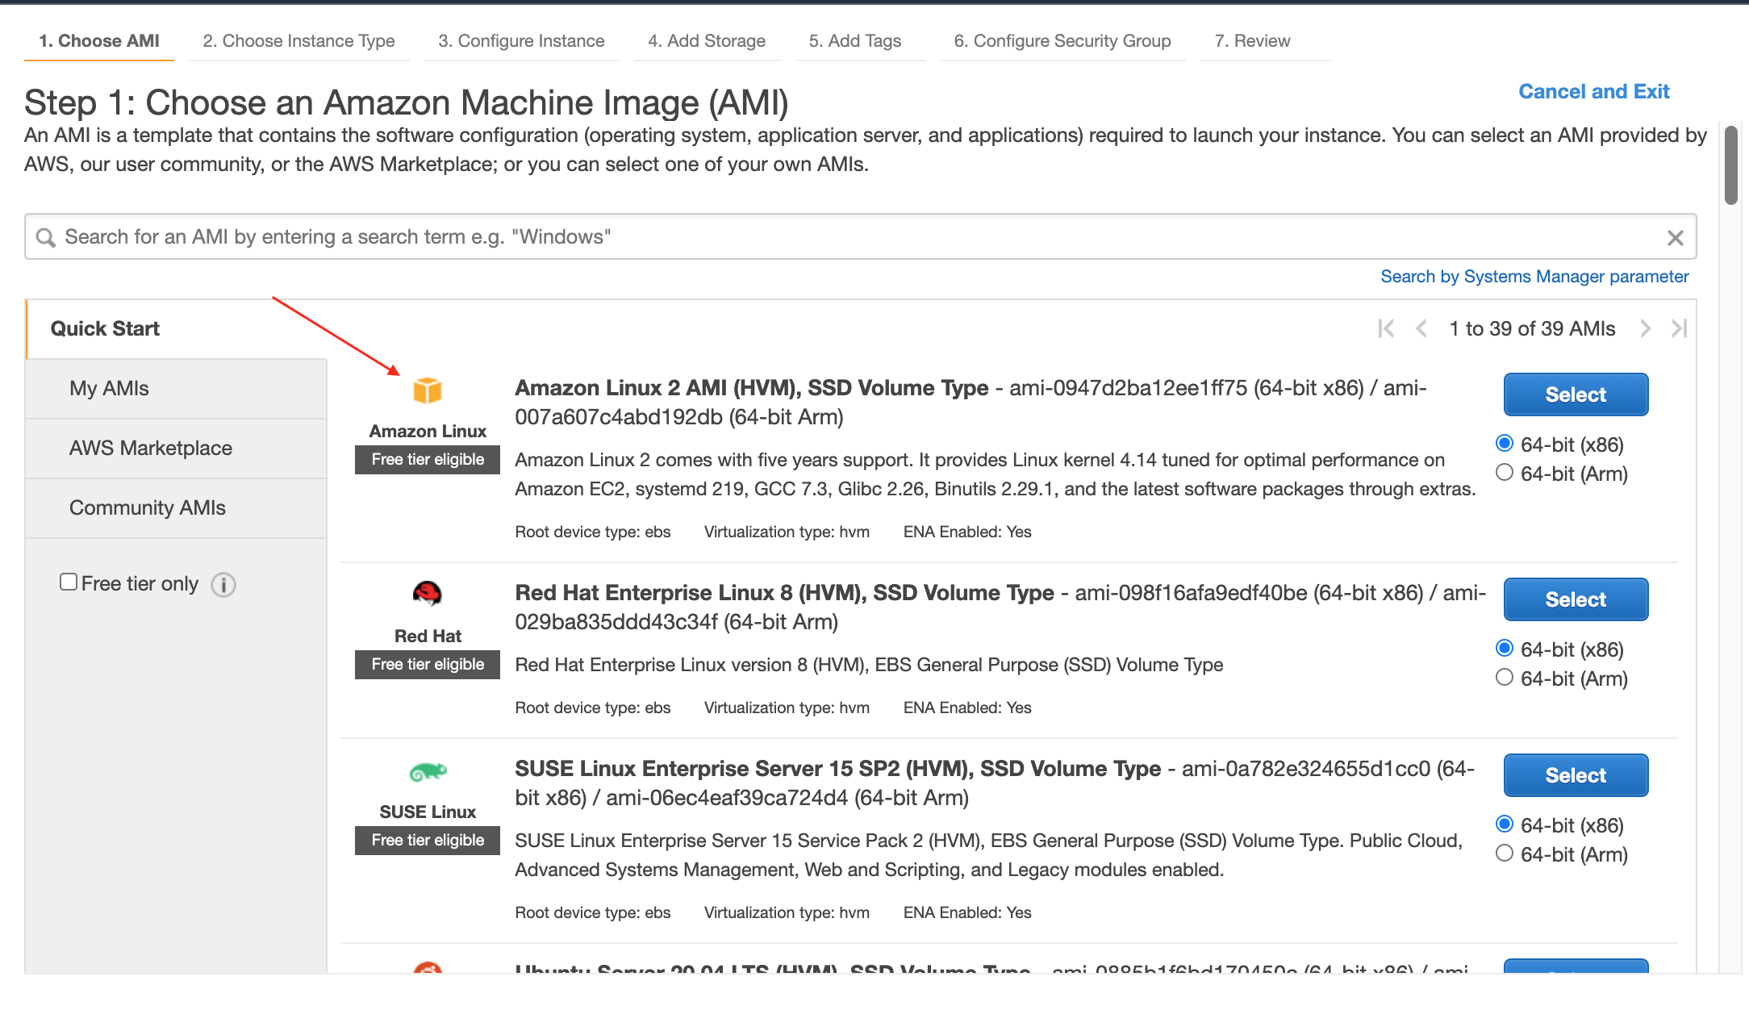

By default, Amazon place instance type at ‘t2.micro’ – free tier, which is what we want to use for the assignment.

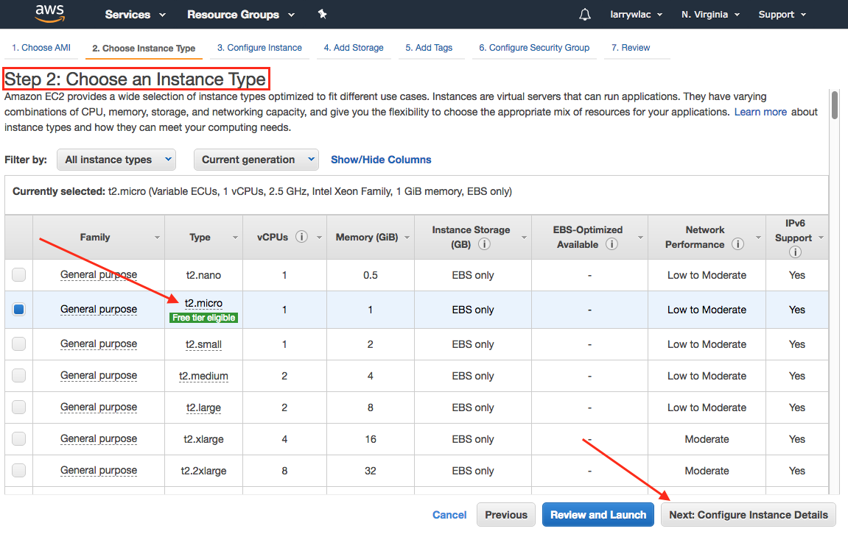

The details: default settings are fine for us.

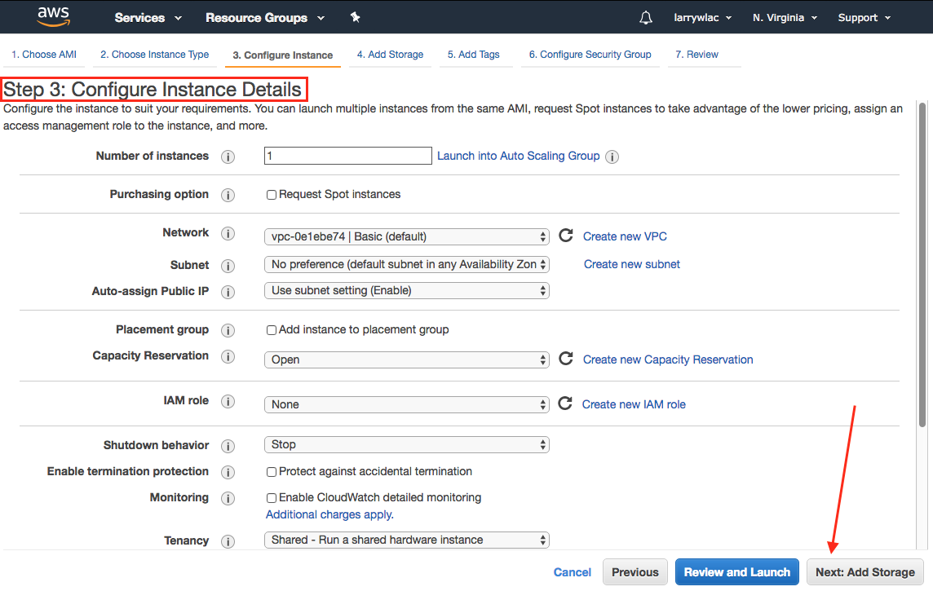

For Storage, (this is for the t2.micro to use for OS), make sure the “Delete on Termination” is checked.

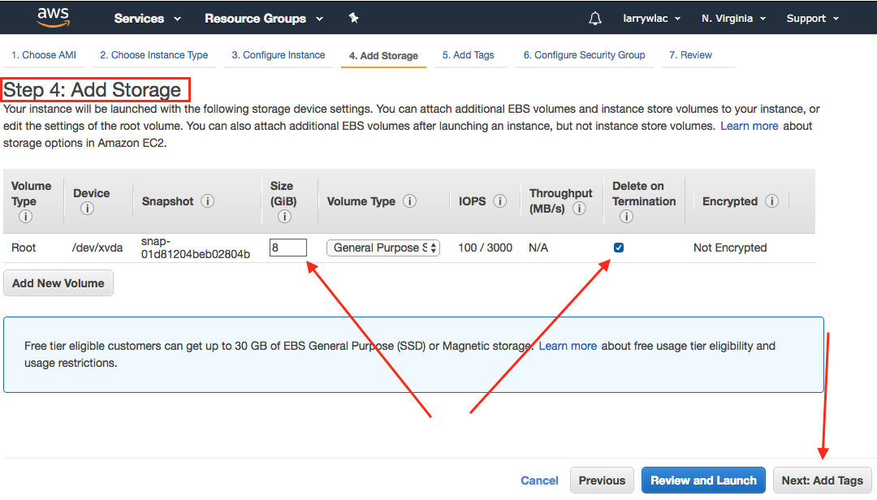

No need to do anything in “Tags”.

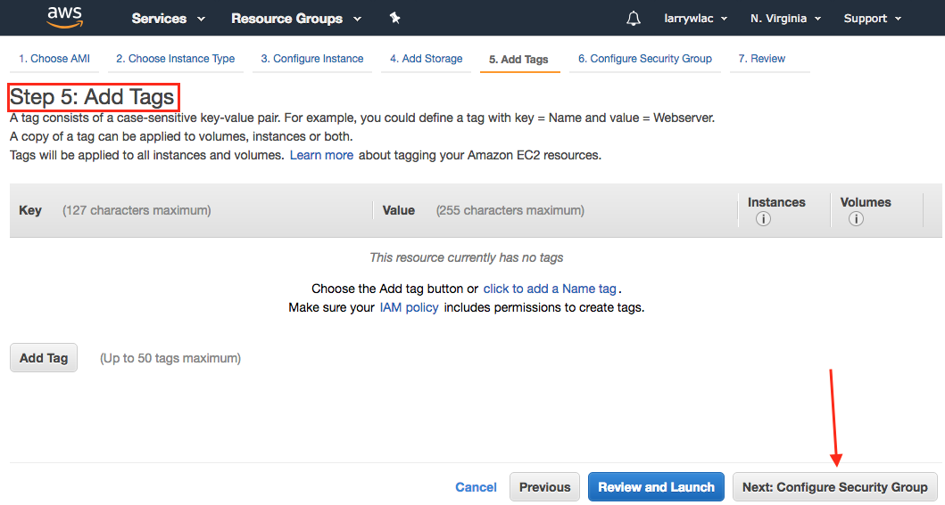

For Security Group, we can select the “Security Group” we created in Assignment 2A, in my case “launch-wizard-1”. If you’ve deleted your “Security Group” in Assignment, just select the option: Create a new security group, just make sure it’s SSH / TCP / 22, source 0.0.0.0/0 and MySQL/Aurora / TCP / 3306, source 0.0.0.0/0

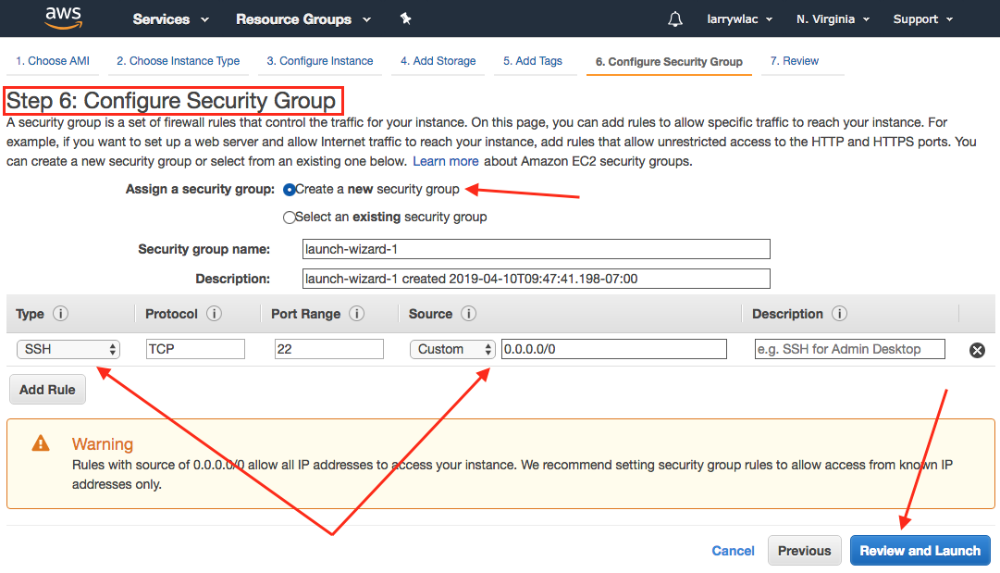

If you choose “Select an existing security group”, AWS will list whatever security groups you have, you can choose one then click “Review and Launch” button.

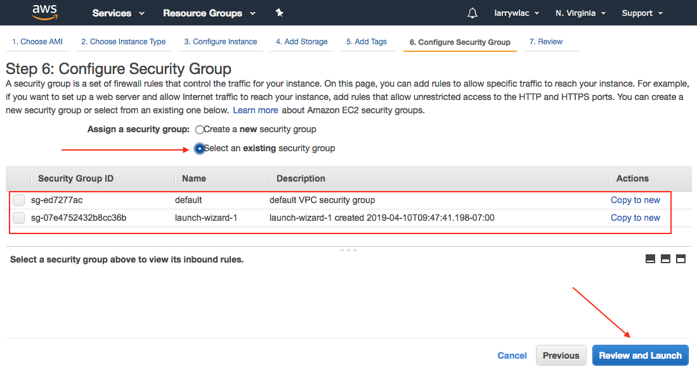

In the “Step7: Review Instance Launch” window, go through your selections, make sure they are what we need. Once confirm, click “Launch”, the “key” screen shows.

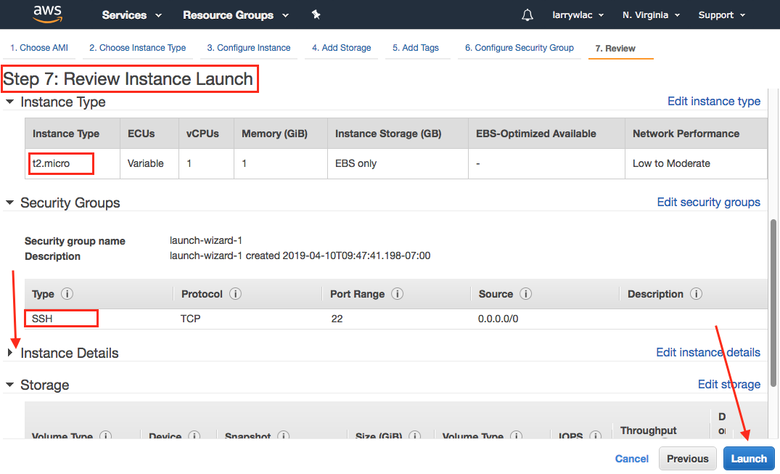

Before actually launch the instance, the Key pair selection screen shows. If not, choose “Create a new key pair”.

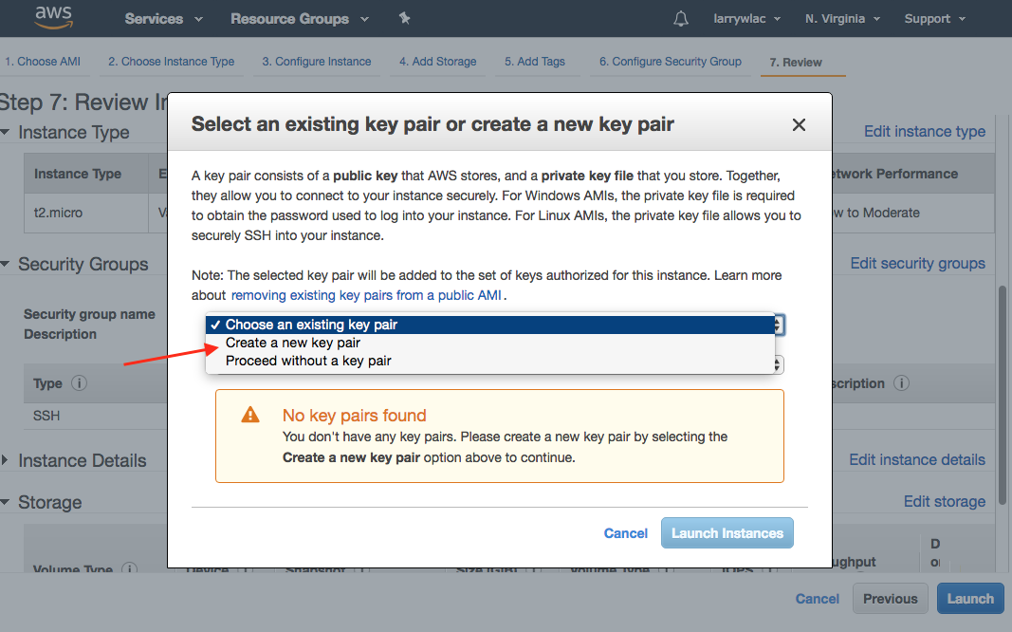

If you create a new key pair, give your key a name, then click “Download Key Pair” option, save your key. Be sure to remember where you save your key.

Once the key is saved, click “Launch Instances”. (Before you download your key, the option will gray out.)

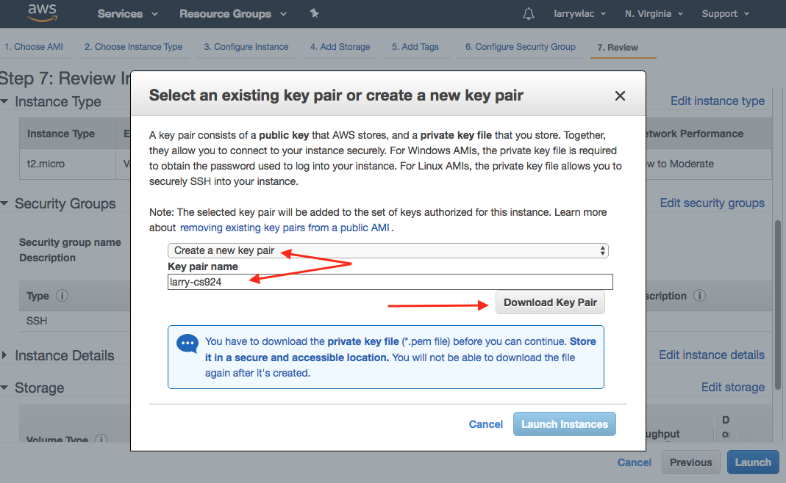

If you have your key you used in Assignment 2A is saved, highlight “Choose an existing key pair”, then select your key (in my case larry-cs24.pem), then click “Launch Instances”.

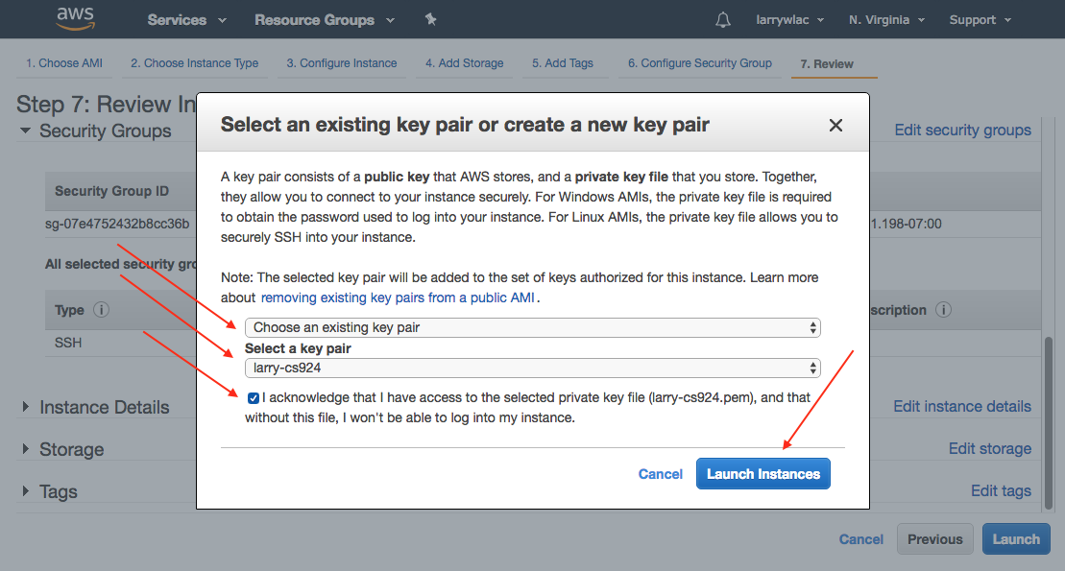

The “Launch Status” screen shows up, click “View Instance” to see your instances in EC2 Dashboard.

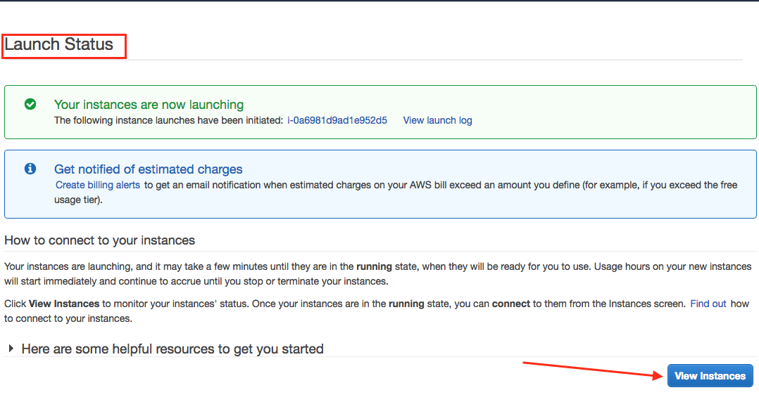

Check the Instance, it should show something similar to this screen.

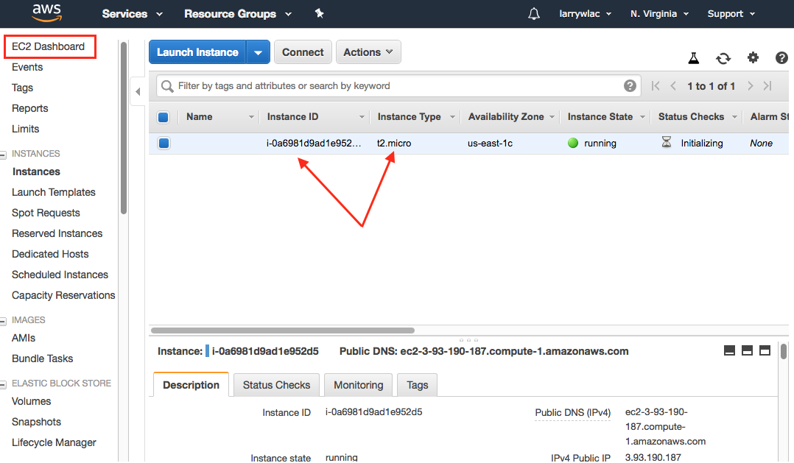

Adjust your screen, look at the bottom half of screen to see the instance details. Pay attention to DNS name, public IP, as you need either of them to make actual connection. Then click the “Connect” button to see the connection instructions.

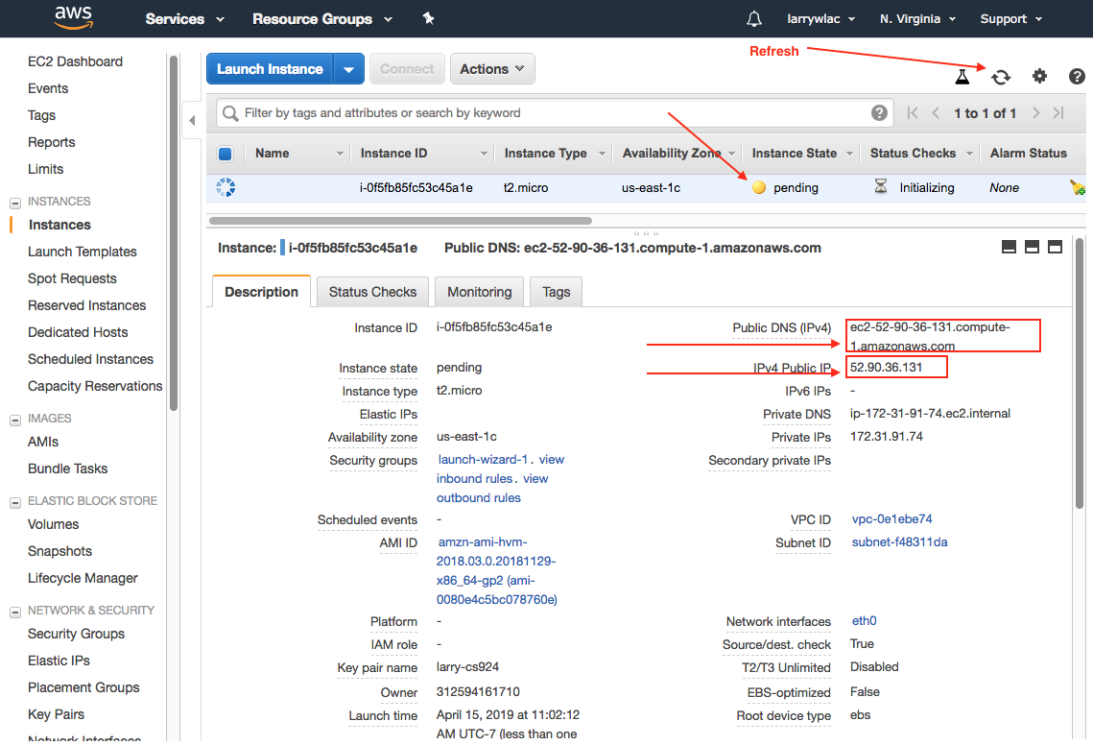

Now the Compute Instance is ready, connection instruction is also available. Let’s connect to our instance to install MySQL Database Server.

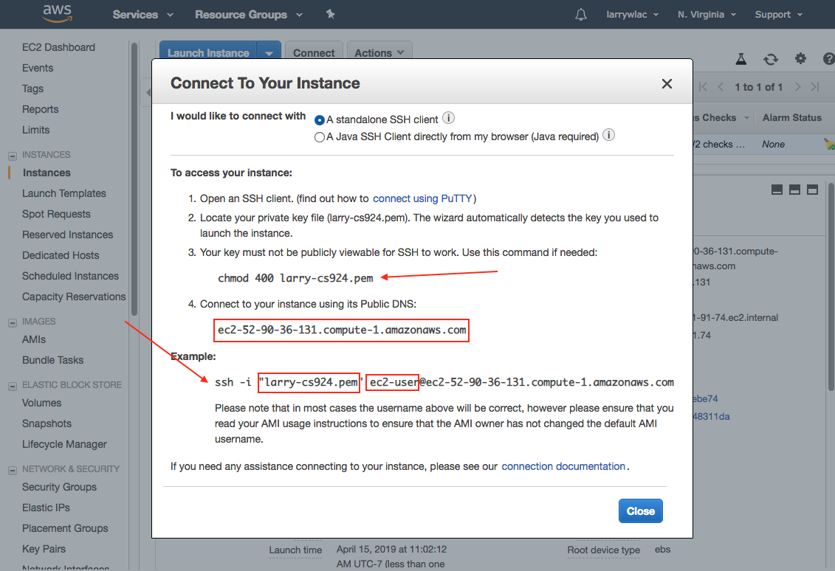

If you’re using Windows, download the “Home Edition” Free version of “mobaxterm” (do a google search, download the “Portable edition” to your computer), double click the zip file to install it!

See bottom of this document for more details.

I don’t have window system, but I have Linux virtual machine, so I use Linux Terminal program here as example.

Note: after the ‘-i’ make sure to include full path to the pem file.

1. Connect to your instance and install MySQL packages.

Run ‘ssh –i larry-cs924.pem ec2-user@ec2-52-90-36-131.compute-1.amazonaws.com’

Note: I recreate the compute instance several times, so the IPs are different in different screenshots. 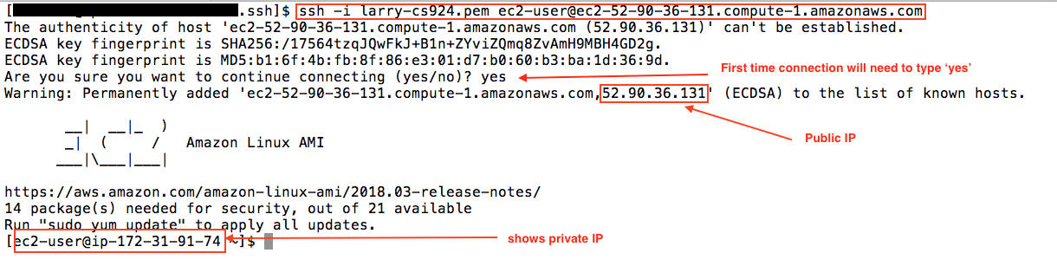

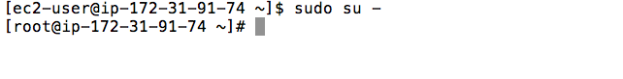

I then run ‘sudo su –‘ to get ‘root’ privilege, as the following instructions will need ‘root’ privileges to perform.

This is only for easy demonstration purposes, under the security baseline, we should always use “sudo <command>” instead.

Run ‘yum install mariadb-server mariadb’ -> yes, mariadb is open source version of Oracle acquired mysql db.

Then start the mariadb-server service:

Run ‘systemctl start mariadb’

And ‘systemctl enable mariadb’

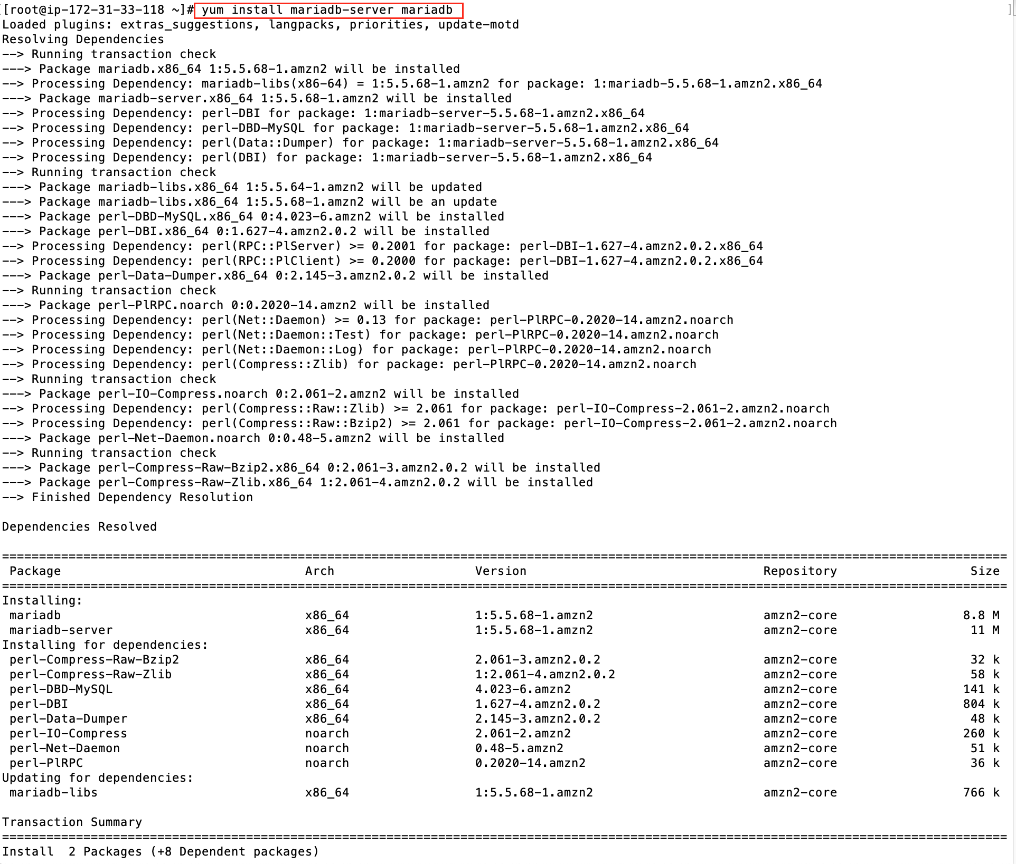

Once the installation completed, we want to start the server daemon and make the service auto start whenever system rebooted.

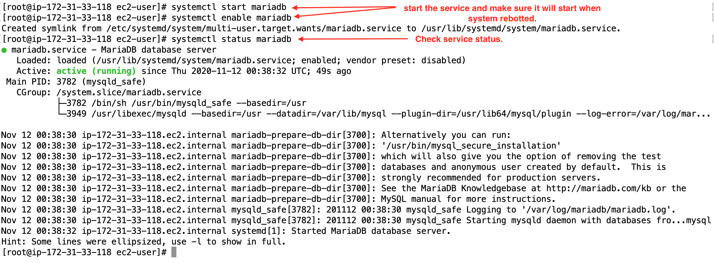

As the program suggested (in the red rectangular box), we’ll want to set the database root password. (mysqladmin is in the search path, we don’t need to type the full path)

mysqladmin -u root password password2019

mysqladmin -u root -h localhost password password2019 -p

The 2nd command line will prompt for password, you will enter: password2019

We set our root password for mysqldb to ‘password2019’.

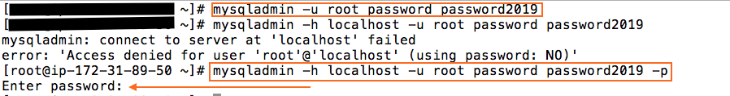

1. Connect to MariaDB server

Run ‘mysql -u root -p’, it will prompt for user root’s password, once connect successfully, you will see the banner, help message, and then the

MariaDB [(none)]> prompt.

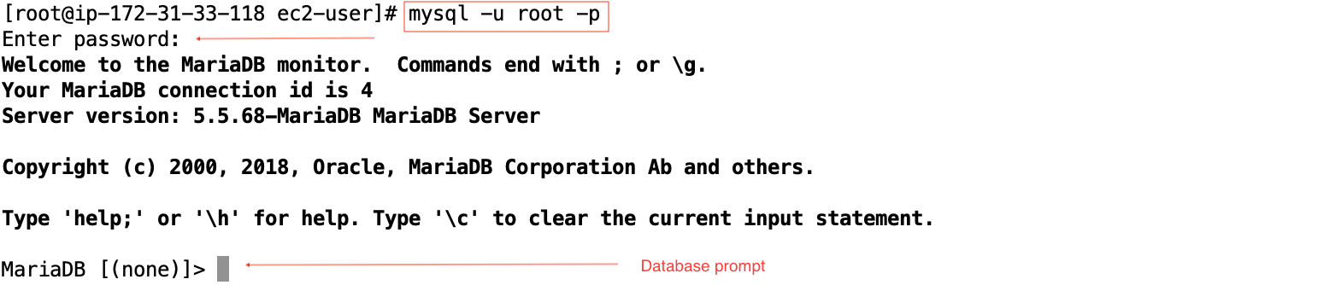

1. Create Database ‘student’

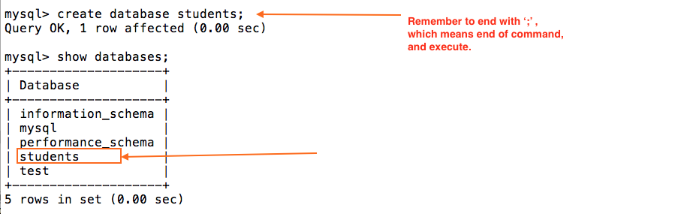

1. Create tables students, modules, grades.

In order to create tables in a database, one must select the database first!!

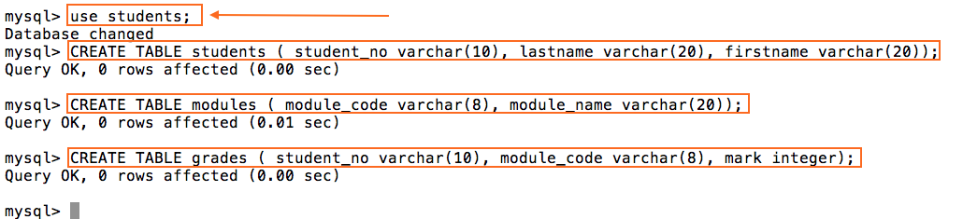

Note: any command entered behind mysql> prompt must end with a semicolon (;) or (\G), otherwise, you can’t execute the command.

1. Populate database.

You can just use your mouse to point and enclose from the first INSERT line to the last, and copy and paste into mysql> prompt:

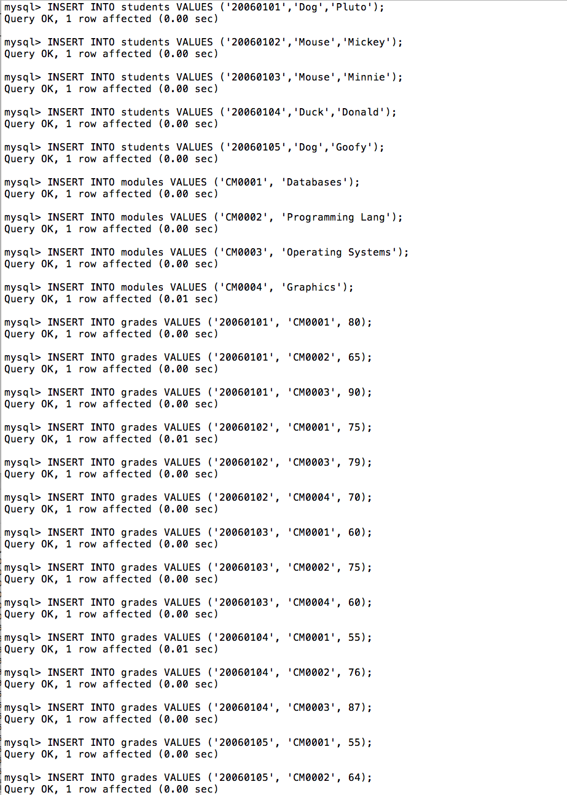

Once the insertions completed, press [Enter] one more time. Then run the following commands, keep the results on the screen, take screenshot of the three results and submit to assignment.

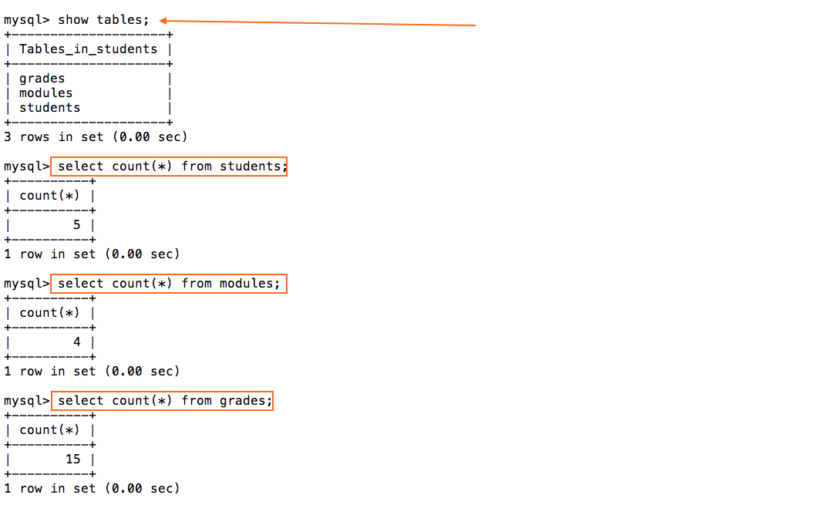

That’s it.

Type ‘quit’ from the mysql> prompt to exit out MySQL console, then ‘exit’ and ‘exit’ to disconnect from the instance.

1. Do not terminate your compute instance as yet, as you will use this same compute instance and MySQL for Assignment 3B !!
2. After you finished Assignment 3B, remember to terminate your EC2 instance.

Good luck!!

Supplemental Instructions for using MobaXterm:

1. Once installation is completed, double click the “MobaXterm” icon or start it up from programs.

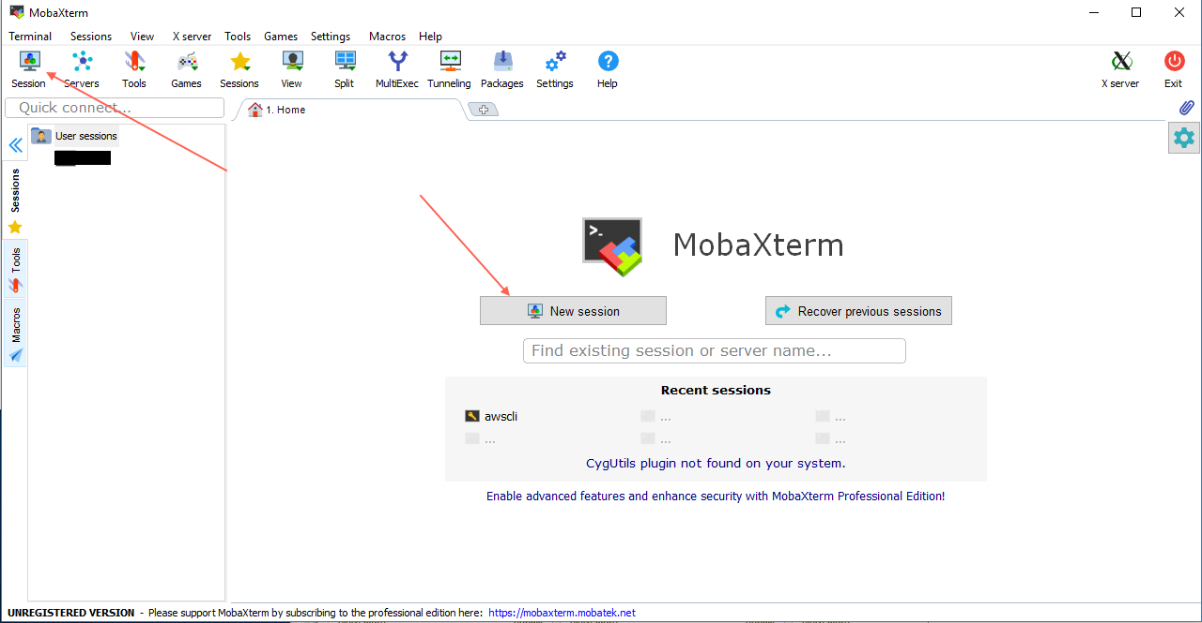

1. Start a new session. (Default is “SSH”)

You will need to “Specify username” -> ec2-user, enter the hostname or IP address of your compute instance, then check “User private key” and browse to where you save your key.

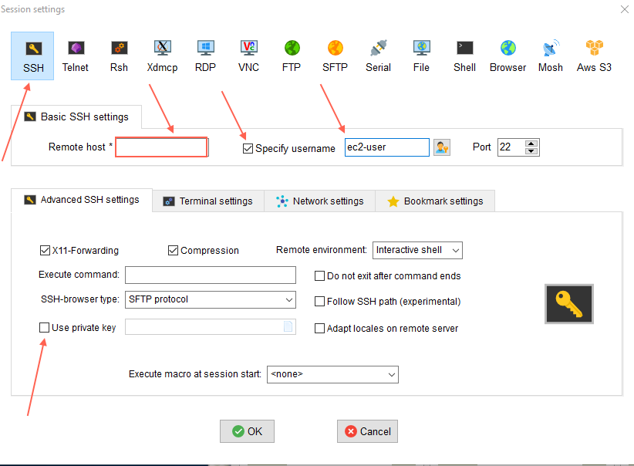

1. Once all the information supplied, click “OK”

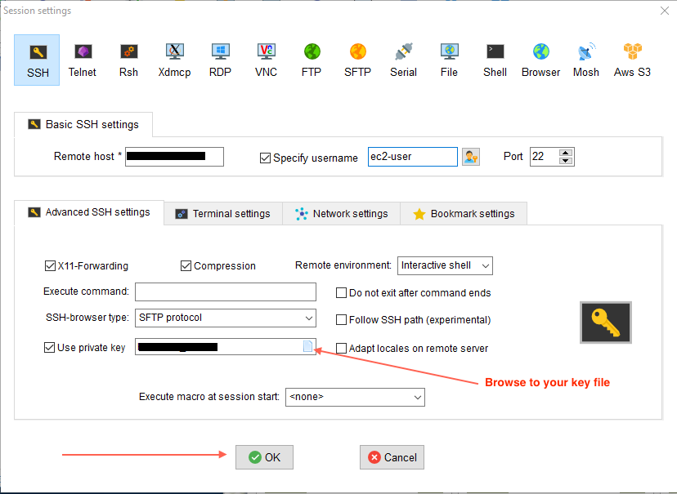

1. Successful terminal session with log in:

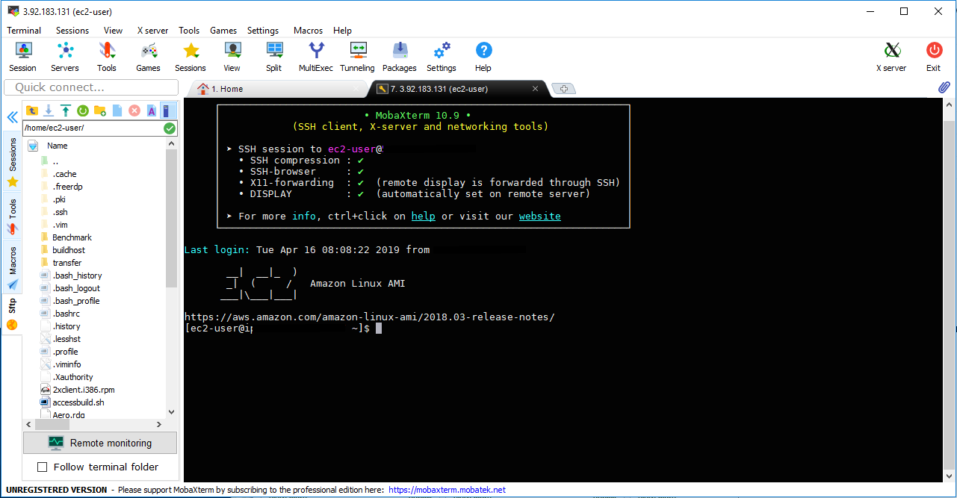

Back to above Step 2 to continue the assignment.